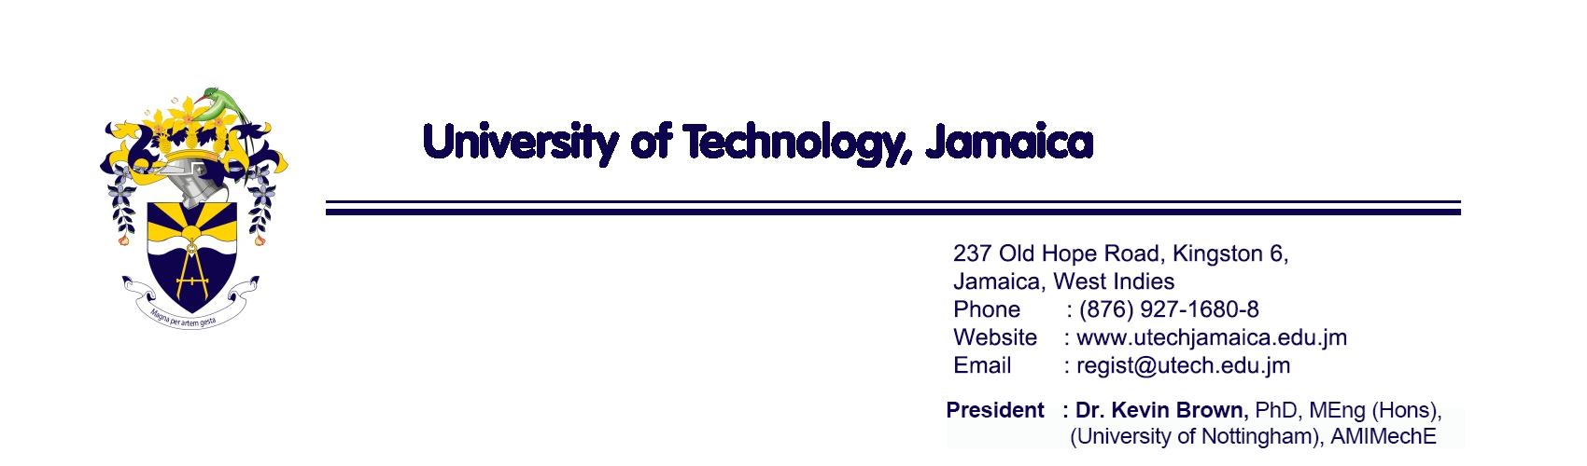
PRESS RELEASE

FOR IMMEDIATE RELEASE

November 6, 2025

University of Technology, Jamaica Announces Resumption of Teaching and Learning Following Hurricane Melissa
The University of Technology, Jamaica (UTech, Jamaica) advises that in-person and online classes will resume on Monday, November 10, 2025, at the Main Campus, Papine, and the Arthur Wint Drive and Slipe Pen Road campuses in Kingston.
MBA Level 2 students will resume classes on Sunday, November 9, 2025.
Classes for students at the Western Campus will resume at the Dome Street campus only, while the Barnett Street (Montego Bay) and Ocho Rios locations remain closed until further notice due to damage sustained during the hurricane.
A decision regarding the reopening of the Barnett Street and Ocho Rios locations will be announced once repairs are completed and electricity, water supply, and communication services are restored.
President of the University, Dr. Kevin Brown, emphasized that the institution remains focused on the welfare and support of all staff and students during this recovery period. “Our leadership team continues to assess conditions across the island to ensure that every decision made is in the best interest and well-being of our university community,” he said.

Academic Adjustments
Instructional content will be modified to ensure completion of essential theoretical, practical, and clinical components within the remaining time in Semester 1.
Deans and faculty teams will determine adjustments to assessments and teaching modalities, particularly for programmes requiring clinical or practicum components. Courses of study with professional or external certification requirements will complete those requirements in full.

Temporary Withdrawal with Permission
Students unable to continue their studies this semester due to the hurricane’s impact may apply for Withdrawal with Permission without penalty or impact on GPA. Applications should be submitted in keeping with Regulation 3 of the Student Handbook.

Graduation Postponed
The UTech, Jamaica Graduation Ceremony, previously scheduled for November 8 and 9, 2025, has been postponed. A new date will be announced once confirmed.

Support and Relief Measures

Psychosocial Support
UTech, Jamaica continues to offer counselling and spiritual care through its counsellors and Chaplaincy team.
Students and staff needing support may make contact at:
- Students: studentwelfare@utech.edu.jm | WhatsApp: 658-213-5380
- Staff: staffwelfare@utech.edu.jm | WhatsApp: 658-213-5380

Financial Alleviation and Welfare Assistance
To assist students adversely affected by Hurricane Melissa, the University has implemented the following measures:
- No financial penalty for students withdrawing from Semester 1
- Waiver of late fee penalties for payment deadlines
- Provision of care packages and essential supplies based on need
- JUTC Bus Passes to help reduce transportation costs
- Special Welfare (Hurricane) Grants of up to J$50,000 for affected students
- Special consideration on a case-by-case basis for the 80% exam clearance requirement

Recovery and Rebuilding Efforts
UTech, Jamaica has established an Emergency Operations Centre (EOC) to coordinate its comprehensive recovery programme. The EOC oversees several Recovery Response Teams focusing on Staff and Student Welfare, Teaching and Learning, Medical Outreach, Information and Communication, Infrastructure, Logistics, and Supplies, Warehouse Management, Finance and Procurement and Information Technology.
These teams provide daily briefings, make recommendations, and ensure that all recovery efforts align with university policies and national guidelines.
Dr. Brown commended the resilience of the UTech, Jamaica community, noting, “Together, we will recover and rebuild stronger. The safety and well-being of our students and staff remain our highest priority.”

End.

Contact:
Michelle Beckford
Corporate Communications Manager
University of Technology, Jamaica
Telephone: 970-5299
Email: mbeckford@utech.edu.jm

