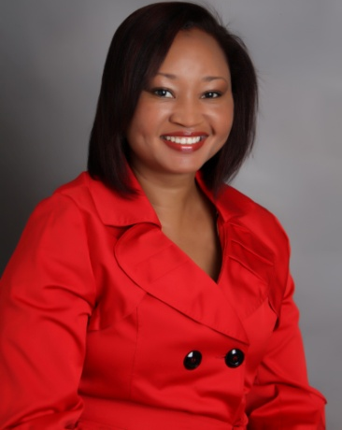 | Dr. Christine Fray-Aiken  Lecturer and DL Liaison OFFICER, College of Health Sciences  Dr. Fray-Aiken was appointed the College of Health Sciences DL Liaison Officer in September 2010. Dr. Fray-Aiken is enthused by technology and has been incorporating animation, video clips, among other resources in her lecture sessions since 2006. Her role involves coordinating training sessions for faculty and facilitating access to modules.  Dr. Fray-Aiken notes that there has been a positive change in faculty attitude and acceptance toward integrating technology into the teaching and learning process based on the increasing number of modules with an online presence in the College.

Ms. Christine O’Sullivan  Lecturer and DL Liaison Officer  Faculty of Science & Sport  Christine O’Sullivan has been the DL Liaison Officer for the Faculty of Science and Sport since September 2016. She, in collaboration with the faculty’s Online Course Development Officer, is responsible for facilitating the creation of both web-assisted and fully online modules in the faculty and enhancing student learning through online applications. | 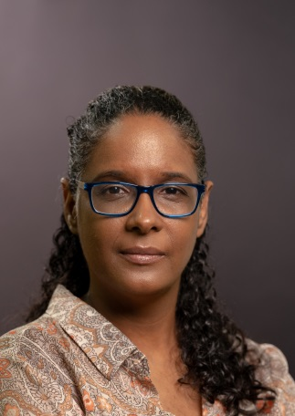

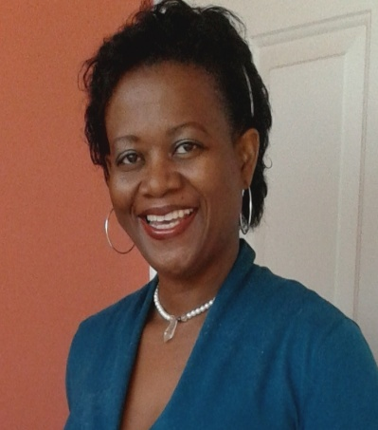 | Mrs. Michelle Stewart-McKoy  Lecturer and DL Liaison OFFICER (OutGoing), Faculty of Education & Liberal Studies  Mrs Stewart-McKoy is the new kid on the block. She assumed the role of DL Liaison Officer for the Faculty of Education and Liberal Studies in August 2014. Her interests include gamification techniques, game-based learning and e-learning-enhanced virtual learning environments, especially the MOODLE platform.  Mrs. Stewart-McKoy envisioned that her role will primarily involve collaboration with the Office of Distance Learning in getting teachers and students to teach and learn with “E’s”.

Mr. Fernandez Anderson  Lecturer and DL Liaison officer  Faculty of Built Environment  Mr. Anderson was appointed the DL Liaison Officer for the Faculty in June 2013. His areas of expertise are AutoCAD and Revit Architecture. He teaches Introduction to Computer Aided Design & Drafting and Computer Aided Design & Drafting in the School of Building and Land Management.  Mr. Anderson has a Bachelor of Construction Engineering & Management (UTech), and a Master of Science in Management (University of Birmingham - UK). | 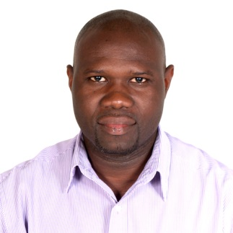

Mr. Alwyn Johnson
Lecturer and DL Liaison Officer
School of Engineering

Lorem ipsum dolor sit amet, consectetur adipiscing elit. Mauris ut interdum sem, a congue felis. Suspendisse ut leo placerat, lobortis diam id, luctus nulla. Quisque sagittis nunc sed justo maximus, a aliquet dui porttitor. Etiam vitae est metus. Nunc in lacus facilisis, suscipit dui vel, porttitor ante. Nulla tinciduNt euismod convallis.

Dr. Paulette Trowers-Lawrence
Lecturer and DL Liaison OFFICER, Joan Duncan School of Entrepreneurship, Ethics and Leadership

Lorem ipsum dolor sit amet, consectetur adipiscing elit. Mauris ut interdum sem, a congue felis. Suspendisse ut leo placerat, lobortis diam id, luctus nulla. Quisque sagittis nunc sed justo maximus, a aliquet dui porttitor. Etiam vitae est metus. Nunc in lacus facilisis, suscipit dui vel, porttitor ante. Nulla tincidunt euismod convallis.

Ms. Karlene Black
Lecturer and dl liaison OFFICER, school of computing & information technology
Lorem ipsum dolor sit amet, consectetur adipiscing elit. Mauris ut interdum sem, a congue felis. Suspendisse ut leo placerat, lobortis diam id, luctus nulla. Quisque sagittis nunc sed justo maximus, a aliquet dui porttitor. Etiam vitae est metus. Nunc in lacus facilisis, suscipit dui vel, porttitor ante. Nulla tincidunt euismod convallis.

Mr. Christopher Colyard
Lecturer and dl liaison OFFICER, school of business administration

Lorem ipsum dolor sit amet, consectetur adipiscing elit. Mauris ut interdum sem, a congue felis. Suspendisse ut leo placerat, lobortis diam id, luctus nulla. Quisque sagittis nunc sed justo maximus, a aliquet dui porttitor. Etiam vitae est metus. Nunc in lacus facilisis, suscipit dui vel, porttitor ante. Nulla tincidunt euismod convallis.

Mrs. Ava Sewell Williamson
Lecturer and DL Liaison Officer
School of Hospitality & Tourism Management

Lorem ipsum dolor sit amet, consectetur adipiscing elit. Mauris ut interdum sem, a congue felis. Suspendisse ut leo placerat, lobortis diam id, luctus nulla. Quisque sagittis nunc sed justo maximus, a aliquet dui porttitor. Etiam vitae est metus. Nunc in lacus facilisis, suscipit dui vel, porttitor ante. Nulla tincidunt euismod convallis.

Lecturer and DL Liaison officer
Joint Colleges of Medicine, Oral Health and Veterinary Sciences

(Vacant)

Lorem ipsum dolor sit amet, consectetur adipiscing elit. Mauris ut interdum sem, a congue felis. Suspendisse ut leo placerat, lobortis diam id, luctus nulla. Quisque sagittis nunc sed justo maximus, a aliquet dui porttitor. Etiam vitae est metus. Nunc in lacus facilisis, suscipit dui vel, porttitor ante. Nulla tincidunt euismod convallis.
Mrs. Takeese Gilpin-Allen
Lecturer and DL Liaison Officer
FACULTY OF LAW

Lorem ipsum dolor sit amet, consectetur adipiscing elit. Mauris ut interdum sem, a congue felis. Suspendisse ut leo placerat, lobortis diam id, luctus nulla. Quisque sagittis nunc sed justo maximus, a aliquet dui porttitor. Etiam vitae est metus. Nunc in lacus facilisis, suscipit dui vel, porttitor ante. Nulla tincidunt euismod convallis.

